LAB ASSIGNMENT- 5

-- 1.

CREATE TABLE emp(

empno int PRIMARY KEY,

ename varchar(20) UNIQUE,

job varchar(10) CHECK (job in ('Prof', 'AP', 'Lect')),

sal int NOT NULL,

deptno int

)

-- 2.

CREATE TABLE dept(

deptno int PRIMARY KEY,

dname varchar(20) CHECK(dname in ('Acc','comp','elect'))

)

ALTER TABLE emp

ADD CONSTRAINT FK_dept

FOREIGN KEY(deptno) REFERENCES dept(deptno)

-- 3.

CREATE TABLE S(

sno int PRIMARY KEY,

sname varchar(20),

city varchar(20)

)

-- 4.

CREATE TABLE P(

pno int PRIMARY KEY,

pname varchar(20),

color varchar(10)

)

-- 5.

CREATE TABLE J(

jno int PRIMARY KEY,

jname varchar(20),

city varchar(10)

)

-- 6.

CREATE TABLE SPJ(

sno int references S(sno),

pno int references P(pno),

jno int references J(jno),

qty int,

PRIMARY KEY(sno,pno,jno)

)

-- 7.

INSERT INTO emp VALUES(1, 'Julia', 'AP', 20000,1)

INSERT INTO dept VALUES(1,'comp')

INSERT INTO dept VALUES(2,'Acc')

INSERT INTO dept VALUES(3,'elect')

INSERT INTO emp VALUES(2, 'Jenna', 'Lect', 60000,2)

INSERT INTO emp VALUES(3, 'Caleb', 'Prof', 90000,3)

INSERT INTO emp VALUES(4, 'Liam', 'Prof', 90000,1)

INSERT INTO emp VALUES(5, 'Mindy', 'AP', 25000,3)

INSERT INTO S VALUES(1,'Danny','London')

INSERT INTO S VALUES(2,'Kaylee','Paris')

INSERT INTO S VALUES(3,'Jacob','New York')

INSERT INTO P VALUES(1,'Handle','Silver')

INSERT INTO P VALUES(2,'Bulb','Gold')

INSERT INTO P VALUES(3,'Base','Black')

INSERT INTO J VALUES(1,'Eureka','Milan')

INSERT INTO J VALUES(2,'Infinity','Dublin')

INSERT INTO J VALUES(3,'Enigma','Quebec')

INSERT INTO SPJ VALUES(1,2,2,6)

INSERT INTO SPJ VALUES(2,1,3,3)

INSERT INTO SPJ VALUES(3,3,1,5)

SELECT * FROM emp

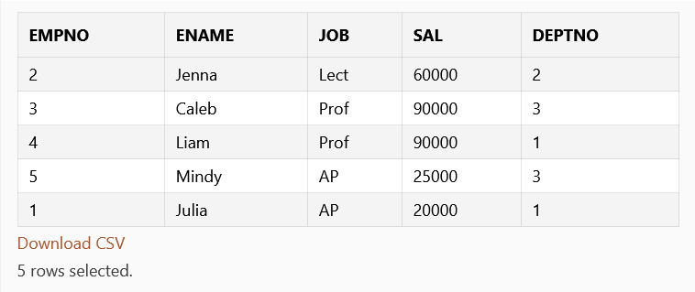

SELECT * FROM dept

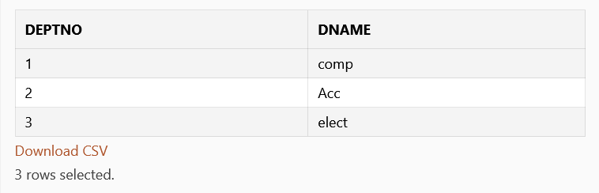

SELECT * FROM S

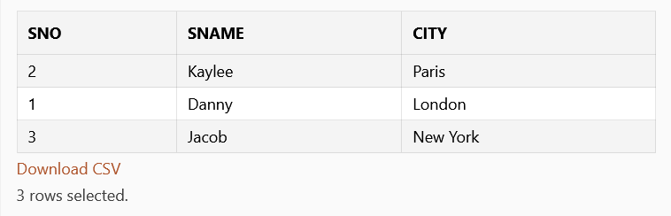

SELECT * FROM P

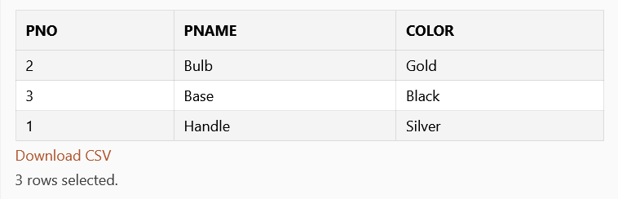

SELECT * FROM J

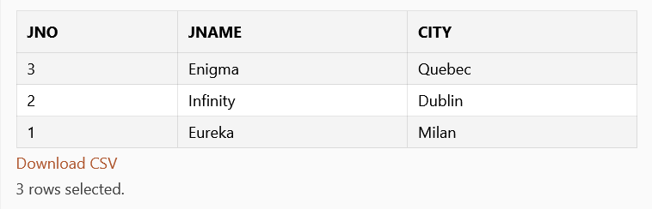

SELECT * FROM SPJ

